|  |  |
| --- | --- |
| No. of Pages | **4** |
| No. of Questions | **4** |

**Department of Computer Science and Engineering**

**MIDTERM EXAMINATION SUMMER 2013**

**CSE421: Computer Network**

**Total Marks: 60 Time Allowed: 70 minutes**



* Answer ALL **FOUR (4)** questions
* Figure in bracket [] next to each question indicates marks for that question



**Question 1**

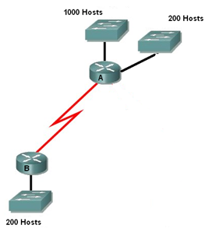

**Figure no. 1**

1. Suppose a company is given a block **195.10.72.0/21.** But you need three more sub networks for your organization and one more for the WAN Link as shown in figure no. 1. Show how you can have 4 more subnets out of the original network address as per host requirements. Do not forget to show basic calculations. [9 marks]



**Figure no. 2**

1. A network associate has to configure the internetwork that is shown in the exhibit above in figure no. 2 so that configuration will allow the hosts on the Branch LAN to access resources on the HQ LAN with the least impact on router processing and the serial links. How can he do so? [3 marks]
2. The **show ip route** command gives the following output.

**C 192.168.2.0/24 is directly connected, Ethernet0/0**

**C 192.168.5.0/24 is directly connected, Serial0/0**

**C 192.168.1.0/24 is directly connected, Serial0/1**

**R 192.168.3.0/24 [120/1] via 192.168.5.1, 00:00:03, Serial0/0**

**R 192.168.6.0/24 [120/2] via 192.168.5.1, 00:00:12, Serial 0/0**

**S 192.168.4.0/24 [1/0] via 192.168.2.1**

**S* 0.0.0.0/0 is directly connected, Serial0/1**

What routing table look-ups will be performed if a packet is addressed to 192.168.4.7? [3 marks]

**Question 2**

1. State 2 disadvantages of distance vector routing protocols? [3 marks]
2. Router R2 is running RIPv2 shown in figure no. 3. Summarize the following networks shown at R2 so that R2 can advertise only one summarized network in its updates instead of the 4 separate networks. Show calculations. [4 marks]

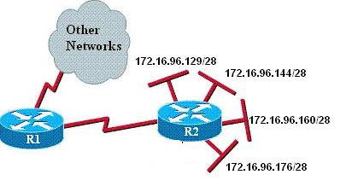

**Figure no. 3**

1. Router B has received an update suggesting that the route to 192.168.9.0 is down. It has set a holddown timer on the route. What event will cause the holddown timer to be removed on that route? What if the Router B receives information of a better metric regarding that route within the holddown timer? [4 marks]
2. How will Router A shown in the figure no. 4 below, choose a path to the 10.1.2.0/24 network if RIPv2 routing protocol is running? What if OSPF routing protocol was running instead of RIPv2? [5 marks]



**Figure no. 4**

**Question 3**

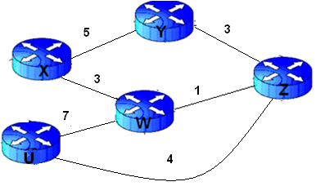

**Figure no. 5**

1. Link state routing protocol uses Dijkstra’s algorithm. Now using Dijkstra’s algorithm, compute the shortest path from Wto all other remote networks shown in figure no.5. Use the table provided. [ 8 marks]



**Figure no. 6**

1. Router1 was just successfully rebooted. Identify the current OSPF router ID for Router1 shown in figure no. 6 and explain why? [4 marks]
2. In DR and BDR selection in a NBMA network, what do you have to do so that a particular router will not be selected as DR neither as BDR? [3 marks]

**Question 4**

1. A router is running IPX and AppleTalk routing protocols simultaneously, how many tables will this router have and why? [3 marks]
2. This line appears in a routing table. What is the origin of this route? [3 marks]

**D*EX 0.0.0.0/0 [170/3651840] via 192.168.10.6, 00:01:08, Serial0/1**

1. Router R1’s neighbor table is shown below in figure no.7, is it correct? If not what should be done to correct it? How are neighbors established? [4 marks]



**Figure no. 7**

1. Refer to the network diagram shown below in figure no.8. Why does RouterA show multiple unequal cost paths to network 192.168.90.0/24? What is the feasible distance, define and show the value of FD for destination network 192.168.90.0/24? Are there any feasible successors to the network 192.168.90.0/24, why or why not? [5 marks]

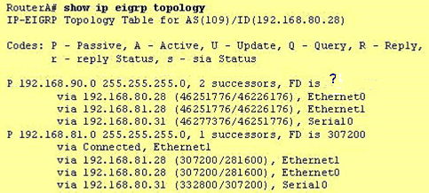

**Figure no. 8**

**THE END**